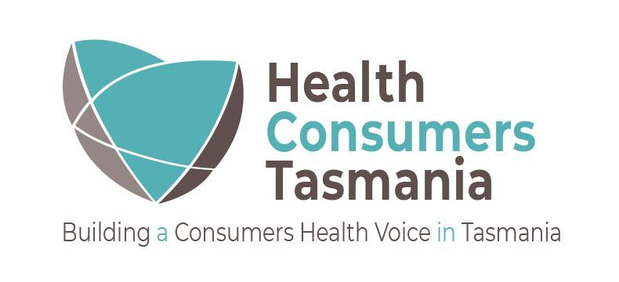

Media release – Coronavirus app 6 May 2020
Tasmanians on track to download the Covidsafe app.
Tasmanians are on track to meet the Prime Ministers minimum target of 40% required to download Covidsafe app.
A recent survey conducted last week by Health Consumers Tasmania, an independent community health advocacy organisation, with analysis undertaken by UTAS, found that approximately 44% of the 435 people surveyed indicated that they have or will download the Covidsafe app.
The Chief Executive Officer of Health Consumers Tasmania, Bruce Levett believes that the app should be something the community seriously considers supporting and is pleased with the result “Health Consumers Tasmania, supports any actions that can be used to make the community a safer place for us to live, particularly during the coronavirus pandemic”.
“Unsurprisingly, given what has happened on the North West Coast with the outbreak, we are not surprised that those on the coast are most likely of all Tasmanians to download the Covidsafe app (at 50%)”.
Nearly a third (30%) indicated they would not download the Covidsafe app whilst a quarter (26%) indicated they didn’t know whether to download the app or not.
“Health Consumers Tasmania believes that it is up to the authorities to provide easy to understand information to allow each Tasmanian to make an informed decision, but unfortunately our survey shows that this has not happened” conceded Bruce Levett.
The reasons given for not downloading the app include security and privacy concerns, as quotes from those completed the survey indicated “I don't have confidence in where my personal data will be stored” and “I don’t trust the government to keep data safe”. Other were concerned about the government messages around the app “The government is already using increasingly coercive language to pressure people to download it, they are not explaining what it can and can't do adequately”.
Mr Levett explains “Our survey has indicated that whilst the levels of support for the app is the same in the North and South, a higher proportion of those in the South have already decided against downloading the Covidsafe app whilst a higher proportion of those in the North were still undecided or didn’t know”.
“The community has a right to ask these questions and I would encourage the Government to listen to their concerns and clearly answer them otherwise we will see more people choose to not download the app”.
Of concern to Health Consumers Tasmania is that people with a disability (51%) were also more likely than other Tasmanians (30%) to not download the Covidsafe app.
“We believe the Government needs to do more to support those vulnerable people in the community as they clearly have concerns about the Covidsafe app or don’t own a smart phone and therefore tend to be left behind”.
To help with transparency Health Consumers Tasmania propose the State Government committee that oversights the management of the data include trusted representatives of the community, to provide integrity to its process, and assurance the data is only used for its intended purposes.
“Tasmanians could benefit from the proposed coronavirus tracing app as it addresses a number of concerns that the public hold so we support its intention but ultimately it will be up to each individual Tasmanian to decide for themselves whether they download the app or not”.

