Revised Media release - Tasmanians have views on the lockdown – 9 May 2020

Tasmanians map a path out of the Coronavirus lockdown.
The Premier of Tasmanian, Peter Gutwein, announced on Friday a broad framework for Tasmania to move out of lockdown. It will have been a welcome message for many who want to go back to work, catch up with family and friends or just have parts of their previous life return. For others, they will be anxious, not knowing what to expect and fearful of further outbreaks in coming months.
The community have confidence in some restrictions being eased in some areas, but not others and this will drive their behaviour for a while longer.
This is the findings of a recent survey of 435 people conducted by Health Consumers Tasmania, an independent community health advocacy organisation, with analysis undertaken by UTAS.
Health Consumers Tasmania asked respondents what restrictions should be lifted in your region after 15 May, found that there are two clear areas that have strong community support.
According to the Chief Executive Officer of Health Consumers Tasmania, Bruce Levett, “Our community of interest has asked that more elective surgeries be allowed to proceed and access to parks and reserves should be considered first with both receiving strong support from the survey with over 70% stating they should be relaxed once it is safe to do so”.
“There is also support to ease restrictions with access to public beaches (58.1% - yes to reduce), family gatherings (51.9%), funerals and weddings (49.4%) and non-essential travel within your region (47.6%)”.
“Those who responded yes aren’t advocating the time is right to quickly move out of lock down but advocate a cautious approach and any easing of restrictions do require a level of community support to be effective”.
To quote those who completed the survey “I think some relaxation but carefully monitored and knowing it may need to change back again”.
According to Mr Levett, “On the other hand, there is little or no public support to ease restrictions for age care (18.4%), shopping – restaurants and cafes (18.6%), non-essential travel around Tasmania (22%), and group exercise / sport (26.1%)”.
The survey also highlighted a significant amount of uncertainty about what to do with the restrictions for schools and other education (19.6% - didn’t know) and age care restrictions (16.4% didn’t know).
“Not surprisingly, these are the two areas where the community have received mixed messages from the different levels of Government, and it appears to have only served to create more uncertainty within the community. For aged care at least, Tasmanians are of the firm view that there should be little change in the short term”.
“The community is also clearly divided on what to do with the restrictions for schools and other education services with a slightly greater number (41.7%) supporting the current restrictions compared to those who would like them eased (38.7%).
“The graph provides the State Government with a road map that outlines the order in which the community are comfortable with the easing of restrictions”.
“On balance, I think the Premier has got the mix about right, but it also shows the Government where they need to work harder and provide the public with clear information on, for example, the level of safety for kids going back to school, the opening of cafes and restaurants and group exercise”.
“The community’s views on these issues are important as they know what level of risk they are prepared to tolerate as we emerge from the coronavirus”.

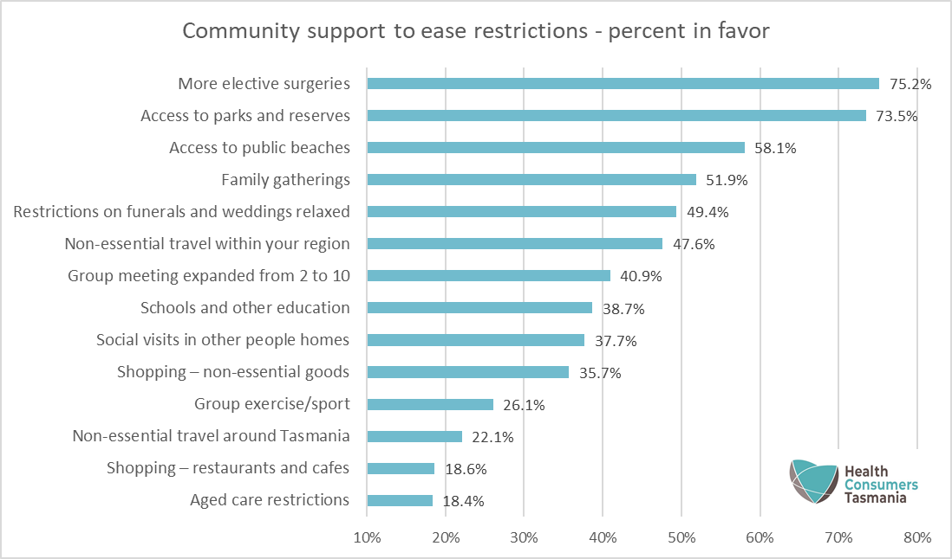

Media contact:
Bruce Levett b.levett@chf.org.au
Chief Executive Officer 0418 503 126
Health Consumers Tasmania www.healthconsumerstas.org.au

